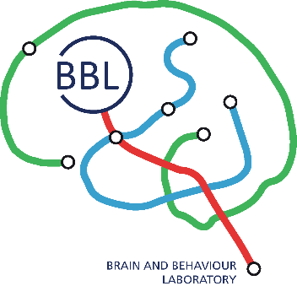

Application form for mri research project at the Brain and Behaviour Laboratory

Acceptance (completed by BBL manager)
Code: | Project duration:

Before a project can use the MRI infrastructure for neuroscience research, it must be reviewed and approved by the BBL's coordinating scientific committee. The evaluation of the projects is done on a scientific, technical and administrative level.

general informations (to be completed by the principal applicant)
Title of the project:

Name of the applicant:
Phone: | Email:
Institution: | Department: | Principal Investigator:
Adress:

Collaborators :
Mri opérator (trained and certified at bbl) in collaboration on the project :
yes : __________________________________ no
Phone : | Email:
Source of funding for the project :

FNS Europe Foundation Other: ________________________________________
Duration : _______________________ Amount : _______________________________________

Agreement of the ethics commitee:  yes / no / in progress | If yes, please attach the approval document
Needs for the project :
Amount of mri hours (Please take into account a margin in order not to overflow on the following experiment in case of delay) : _________________ hours
mri operator for acquisition : yes / no
Visual stimulation : yes / no
Auditory stimulation : yes / no
Olfactory stimulation : yes / no
Gustatory stimulation : yes / no
Tactile / thermal / ELECTRICAL stimulation : yes / no
eye-tracker : yes / no
physiological measurements biopac : yes / no
nirs : yes / no
eeg : yes / no

Other (spécify) : _____________________________________________________________
RESEARCH PLAN (SUMMARY):
Aims, importance of the project, MRI techniques used (DTI, fMRI, particular sequences, etc.), total duration per MRI examination, number of examinations and dates. Also to be mentioned: special equipment, archiving, data transfer.

Research involving patients (clinical research): yes / no
Responding Physician :
Phone: | e-mail:

