Preparing the Olfactometer:
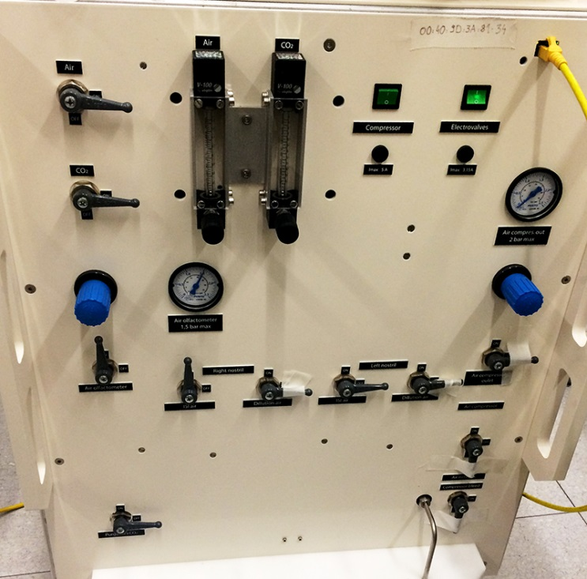
1. Plug it in the power cable into wall (P)
Y
2. Plug in the yellow Ethernet cable (Y)
E
I.
3. Turn Electrovalves (E) on
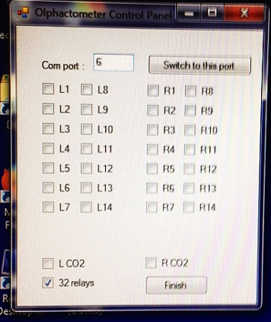
    - Can already test whether olfactometer is being read by the computer
      - On the desktop -> Icon that says Test olfactometer
IV.
      - Click on one of the options on the left side (Port 4 for PPL, Port 6 for fMRI) to see if it is connected. If you hear a clicking sound from the olfactometer, then it is connected.
P
III.
II.
4. Turn ON
    - Air
    - Air Olfactometer
    - Right nostril - ISI air
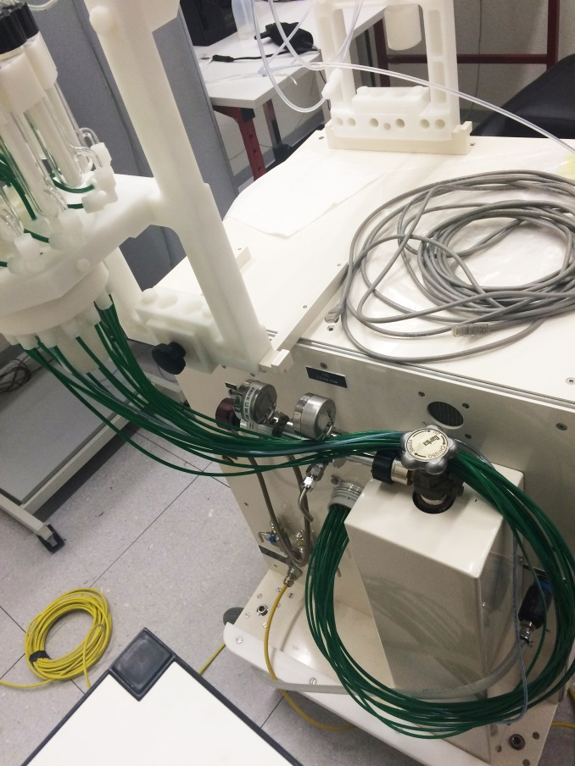
    - Air olfactometer should be set at 1.5
    - The rest should be OFF
5. Plug in the cable for the air in the olfactometer (Air Network inlet -ANI) and in the Air technique pipe on the wall by the sink. Should hear 2 clicking sounds when you plug the cable for both ends
B
6. Turn on the Air from the wall using the handle (it’s on when the handle is horizontal)
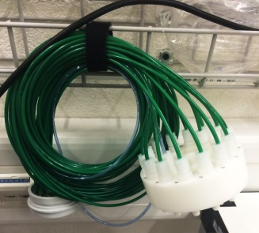
7. Plug in the odors to the olfactometer using the connector with green cables.
A
A
B
i) Connect part A to the olfactometer
ANI
ii) Unscrew the cap underneath the vials in order to plug part B underneath the vials
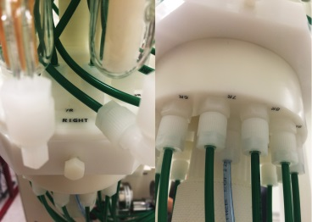
iii) Attach part B, while making sure to match the numbers on the vials side of the olfactometer and the numbers on part B
Below
Above
iv) Screw cap back once part B is in place

8. Clean nasal cannula
- Use toilet paper and Alcohol
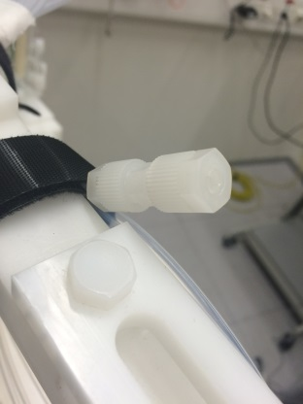
9. Connect nasal cannula to olfactometer. Connect the side that has not been blocked off.
- Unscrew part Z to be able to insert cannula
Z
- Insert cannula
- Tighten part Z but not too tight

At the end of the session
1. Unplug everything turn off the olfactometer and unplug everything you’ve plugged.

Troubleshooting
If the olfactometer is not working:
1. Check everything is plugged in correctly
2. Go into digi Realport, see if the olfactometer is present on the list
- If it is and it is still not working, try re-installing it.
- the IP address can be found on the olfactometer by the yellow Ethernet cable.
If it still does not work:
- Contact Sylvain Delplanque: 90905

